**Task 3:** HTML/CSS/JavaScript

1. When hovered over the menu, the menu items should change background color as shown below.



1. Create a Careers.html page that looks as below. The original image file is provided separately in the zip folder also.

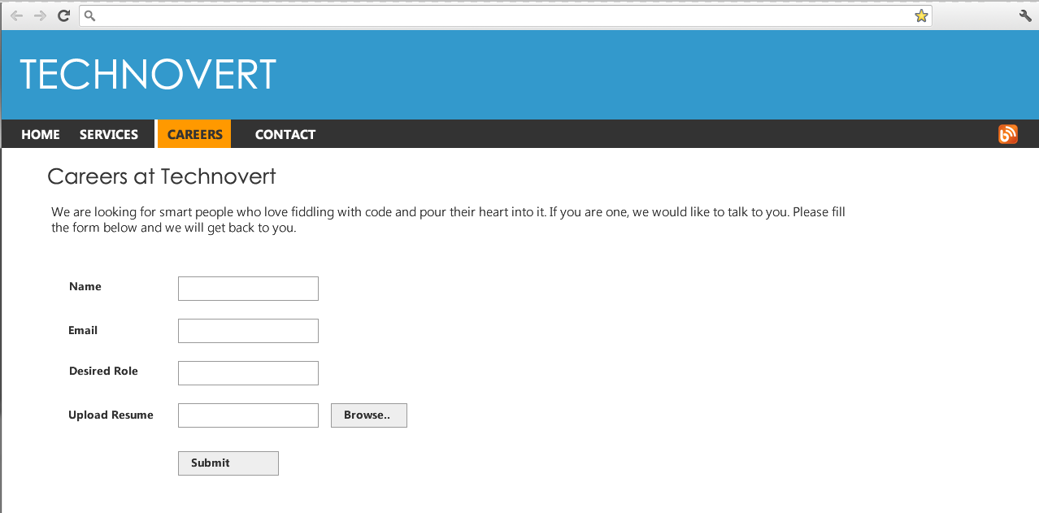

1. Please add the following contact form on the Contact Us page. The fonts should be same as the previous screen (ignore the font in sceen below).

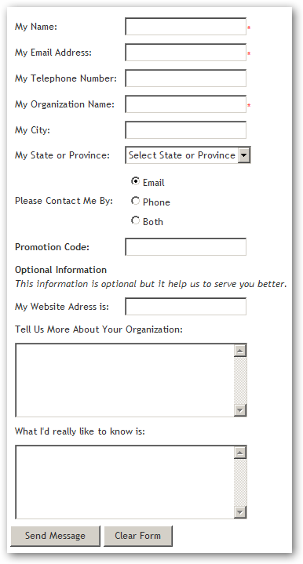

The state dropdown allow contains a list of states.

**Java script:**

1. When you click on the Clear Form button, you need to clear all the fields through java script.
2. When I changed the state drop down list value in the above image, show the selected value in the Promotion Code text field and append the word ‘-PROMO’.  
   Ex: Andhra Pradesh – PROMO
3. Add two radio buttons on this page for Gender - Male, Female. And when selection changed, show the following alerts for each respectively.   
   “Hello Sir” “Hello Lady”
4. The fields – Name, email and organization name are required. If the user attempts to submit the form without entering this information, show the following error message above the form

**Please fill all the required fields below**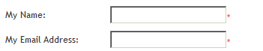

**Bonus**

1. Please also show the error message against each of the field. 

Email is required

Name is required

1. Validate that the email address is of the correct format.  
   Ex: [xyz.123_abc@hyd-office.co.in](mailto:xyz.123_abc@hyd-office.co.in)

Xyz#123@office.com is wrong  
abc@abc.usa@super.net is wrong